**Participants:**

Sai Sri Harsha Chakravarthula **- 11547144**

Narendar Reddy Nelakurthi **– 11554694**

**Example:**

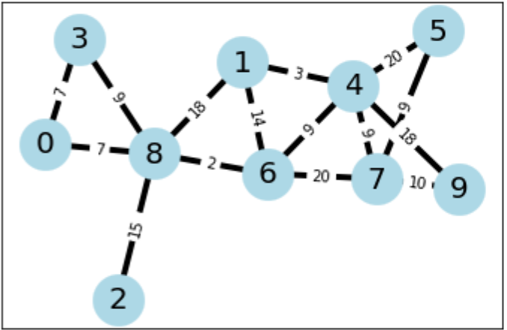

**Pseudo code:**

1. V = Initialise (Graph, Vertices);
2. S, D, T = Initialise (Start node, Destination node, start time);
3. Queue Q = [all the Vertices in the V];
4. SP {} = shortest_path_nodes (S, D) /*Example shortest path from 2,8 in example {2,8,6,4} initially */
5. P = SP [0]
6. IT (initial time) = T
7. For (P is not NULL):
8. IF (P is not equals to D):
9. P= SP [1]
10. Drop (SP [0] FROM SP)
11. Get new time Current T
12. IF (T >= IT+15):
13. p = norm (mu, std)
14. Load_factor = p * baseload * edge_length ] /* Calculate the load factor*/
15. Overall load = (sum of all % increases in P)/size(P)
16. IF ( Overall load >= 5):
17. Queue Q = [Re adjust the weights ]
18. ELSE :
19. Go with the current Q values i.e. do not re adjust the weights

**Flow Chart:**

